**Smart Home Automation**

**Introduction:**

Smart Home automation is a project which basically automates the basic home appliances according to the ease of user. The main motive of this project is to ease the work of user and automate the tasks based on the surrounding environment and time of the day. In this project the home systems of a Aircon is automated based on the room temperature and displayed on a LCD display.

**Objectives:**

1. To display the temperature on the LCD display.
2. To automate the Aircon based on the room temperature.

**Benefits:**

It makes the users work easy by automating the tasks as he/she doesn't need to manually do these tasks. Also, the power can be saved when the appliances are kept powered on un-necessarily. This is also cost as well as energy efficient.

**High Level Requirements:**

| **RID** | **DESCRIPTION** | **STATUS** |
| --- | --- | --- |
| HLR1 | To turn on the Aircon when the temperature rises above certain level | Implemented |
| HLR2 | To display the temperature on the LCD display | Implemented |

**Low Level Requirements:**

| **RID** | **DESCRIPTION** | **STATUS** |
| --- | --- | --- |
| LLR1 | To interface Temperature Sensor (Thermistor) with AVR | Implemented |
| LLR2 | To interface LCD Display with AVR | Implemented |
| LLR3 | To interface Aircon (Here depicted by a LED) based in Thermistor reading | Implemented |

# ****Architecture Details****

## ****Microcontroller Used****

### ATMEGA32

ATmega32 is eight-bit higher enactment microcontroller, it is manufactured by an Atmel. It is founded on enriched RISC which stands for (Reduced Instruction Set Computing) design which consists of 131(one thirty-one) potent commands. Mostly commands implement in one mechanism sequence. The maximum frequency at which it operates sixteen MHz. It works on 1.8 to 5.5 volts.

### Pin configuration of ATMEGA32

| **Pin#** | **Type** | **Parameters** |
| --- | --- | --- |
| Pin#1 | PB0 (XCK/T0) | it is the zero pin of port B. |
| Pin#2 | PB1 (T1) | it is the one no pin of port B. |
| Pin#3 | PB2 (INT2/AIN0) | it is the no two pin of port B. |
| Pin#4 | PB3 (OC0/AIN1) | it is the three no pin of port B. |
| Pin#5 | PB4 (SS) | It is the no four-pin of port B. |
| Pin#6 | PB5 (Master Out Slave In) | It is the pin no five of port B. |
| Pin#7 | PB6 (master in slave out) | It is the pin no six of port B. |
| Pin#8 | PB7 (Serial clock) | this is the pin no seven of port B. |
| Pin#9 | RESET | It is the reset pin. |
| Pin#10 | Vcc | It is the supply voltage of plus five volts. |
| Pin#11 | GND | It is the ground terminal. |
| Pin#12 | XTAL2 | it is linked with the Crystal Oscillator. |
| Pin#13 | XTAL1 | this pin is also linked with the Crystal Oscillator. |
| Pin#14 | PD0 (RXD) | it is the zero pin of port D. |
| Pin#15 | PD1 (TXD) | It is the pin no one of Port D. |
| Pin#16 | PD2 (INT0) | it is the pin no two of port D. |
| Pin#17 | PD3 (INT1) | it is the pin no three of port D. |
| Pin#18 | PD4 (OC1B) | it is the pin no four of port D. |
| Pin#19 | PD5 (OC1A) | it is the pin no five of port D. |
| Pin#20 | PD6 (ICP) | it is the pin no six of port D. |
| Pin#21 | PD7 (OC2) | it is the pin no seven of port D. |
| Pin#22 | PC0 (SCL) | it is the pin no zero of port c. |
| Pin#23 | PC1 (SDA) | it is the pin no one of port c. |
| Pin#24 | PC2 (TCK) | it is the pin no two of port c. |
| Pin#25 | PC3 (TMS) | it is the pin no three of port c. |
| Pin#26 | PC4 (TDO) | it is the pin no four of port c. |
| Pin#27 | PC5 (TDI) | it is the pin no five of port c. |
| Pin#28 | PC6 (TOSC1) | it is the pin no six of port c. |
| Pin#29 | PC7 (TOSC2) | it is the pin no seven of port seven. |
| Pin#30 | AVcc | It is the Vcc for interior ADC. |
| Pin#31 | GND | it is the ground terminal. |
| Pin#32 | AREF | It is the Analog Reference Pin for ADC. |
| Pin#33 | PA7 (A/DC7) | it is the pin no seven for port A. |
| Pin#34 | PA6 (A/DC6) | It is the pin no six for port A. |
| Pin#35 | PA5 (A/DC5) | it is the pin no five for port A. |
| Pin#36 | PA4 (A/DC4) | It is the pin no four for port A. |
| Pin#37 | PA3 (A/DC3) | it is the pin no three for port A. |
| Pin#38 | PA2 (A/DC2) | it is the pin no two for port A. |
| Pin#39 | PA1 (A/DC1) | it is the pin no one for port A. |
| Pin#40 | PA0 (A/DC0) | It is the pin no zero for port A. |

## Sensors Used:

### **Thermistor**

Thermistor sensor is a resistance thermometer highly sensitive to small changes in temperature, and is an economical means of precisely sensing heat over a limited range of temperatures. These sensors utilize a metal oxide whose change in resistance is typically an inverse function of the change in temperature.

## ****Display****

A 16x2 LCD display is used to display. This display can provide 2 lines of 16 characters each.

## Explanation:

The thermistor will capture the analog data from the environment which will be converted to digital data using ADC port on ATMEGA32. The data is in the form of resistor reading, using the resistor value and using the formula the resistor value is then converted into temperature value. Then the temperature and the resistor value both are displayed on the LCD which is connected to the AVR. The temperature value is then compared with some value and if the temperature exceeds some particular value, then the Aircon is switched on automatically.

[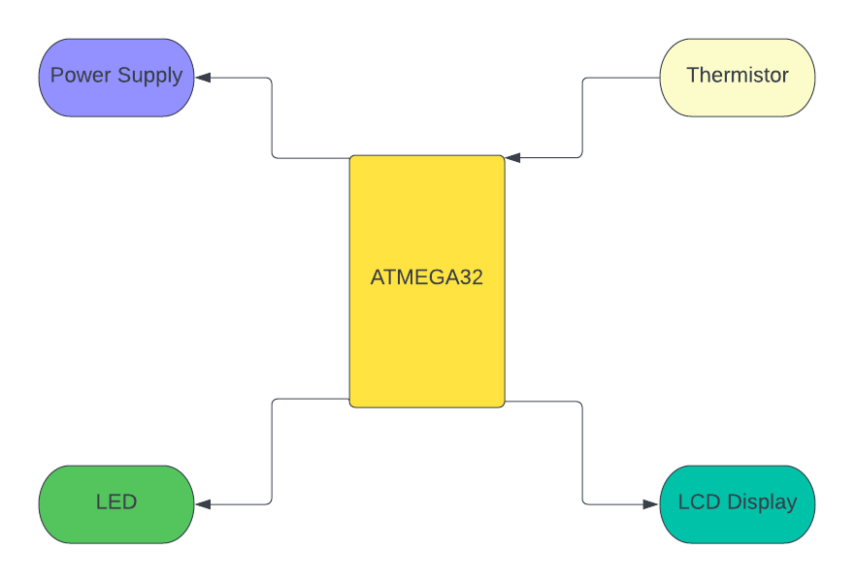](https://user-images.githubusercontent.com/47058068/157287824-f86a74f4-e910-4676-976b-6c9bb02011c0.png)

[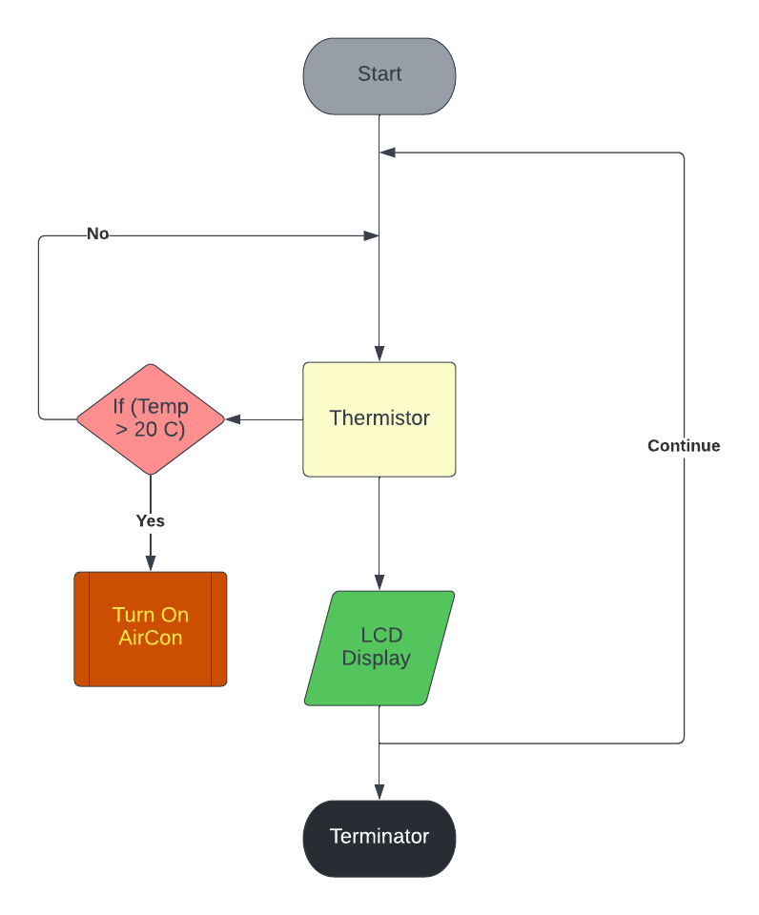](https://user-images.githubusercontent.com/47058068/157283578-26924590-314a-4497-91cb-9c89f20c990e.png)

# Simulation Pics

## Circuit Diagram:

[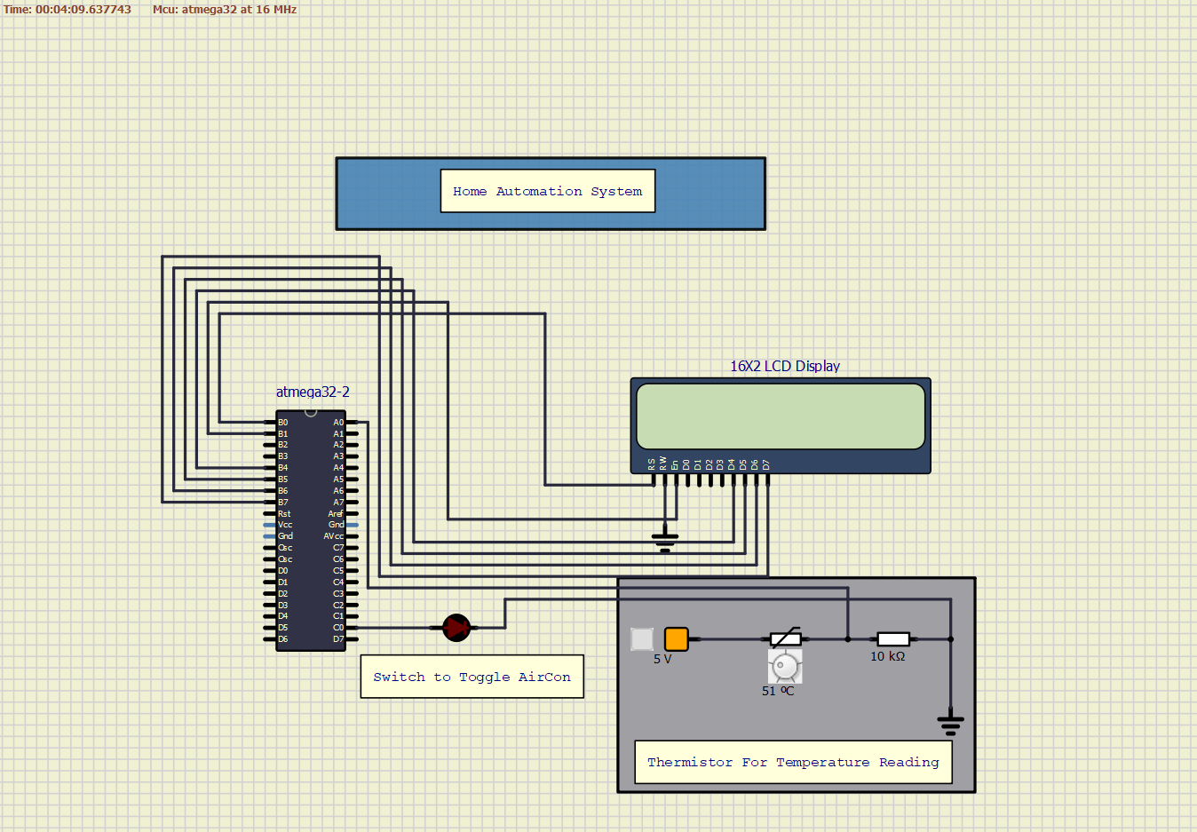](https://user-images.githubusercontent.com/47058068/157298487-71fe1b38-cc2b-4def-b026-f2743fc60562.png)

## Aircon OFF (LED OFF) when temperature less than 20 C:

[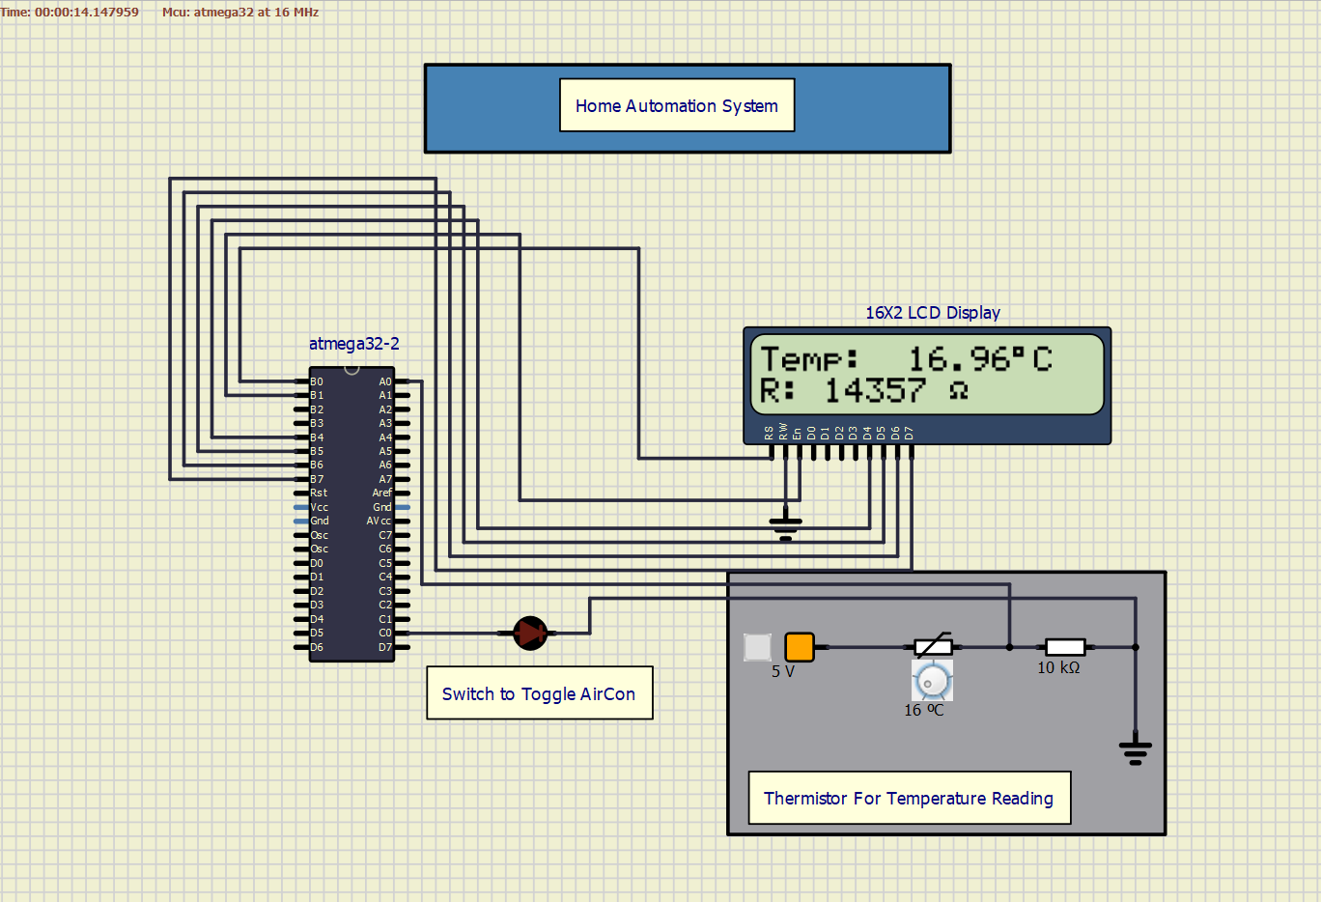](https://user-images.githubusercontent.com/47058068/157298878-5203ee70-1f6d-49d0-b18f-1a468bd70b96.png)

## Aircon ON (LED ON) when temperature greater than 20 C:

[](https://user-images.githubusercontent.com/47058068/157298878-5203ee70-1f6d-49d0-b18f-1a468bd70b96.png)

**High Level Test plan**

| **Test ID** | **Description** | **Exp I/P** | **Exp O/P** | **Actual Output** | **Type of Test** |
| --- | --- | --- | --- | --- | --- |
| HLT_1 | Integrate Thermistor with Microcontroller | None | Successful Integration | Successful Integration | Requirement based |
| HLT_2 | Integrate the LCD display with the Microcontroller | None | Successful Integration | Successful Integration | Requirement based |
| HLT_3 | Integrate LED with Microcontroller | None | Successful Integration | Successful Integration | Requirement based |

**Low Level Test plan**

| **Test ID** | **Description** | **Exp I/P** | **Exp O/P** | **Actual Output** | **Type of Test** |
| --- | --- | --- | --- | --- | --- |
| LLT_1 | Use thermistor to give input to the Microcontroller | None | Successful Integration | Successful Integration | Requirement based |
| LLT_2 | Interpret the temperature of the surrounding using the thermistor data | None | Successful Integration | Successful Integration | Requirement based |
| LLT_3 | To turn on the Aircon if temperature less than certain value | None | Successful Integration | Successful Integration | Requirement based |
| LLT_4 | Display the temperature value and resistance of the thermistor on LCD display | None | Successful Integration | Successful Integration | Requirement based |